OUTPUT:
--- CATEGORY 1: OPTIMIZING HYPERPARAMETERS ---
Optimal Model (Decision Tree) Configuration:
Best Hyperparameters: {'criterion': 'entropy', 'max_depth': 3, 'min_samples_leaf': 5}
Cross-Validation F1-Score: 0.8614

Interpretation & Recommendation (Issue 1):
The best configuration (max_depth=3, min_samples_leaf=5) achieves the highest F1-Score of 0.8614 on the validation data.
The optimal parameters strike a balance between complexity and regularization, indicating a robust model for future deployment. This configuration minimizes the risk of fitting training data noise.

--- CATEGORY 2: OPTIMIZING THE BIAS-VARIANCE TRADEOFF ---
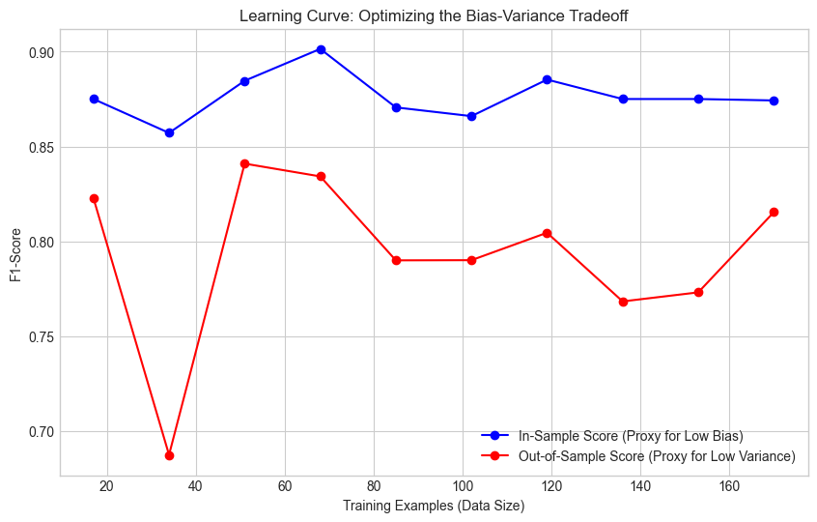
Output from Bias-Variance Analysis (Test Error Check):
In-Sample F1-Score (Training/Bias): 0.8813
Out-of-Sample F1-Score (Testing/Variance): 0.8048
Generalization Gap: 0.0765

Interpretation & Recommendation (Issue 2):
The Learning Curve plot shows the model's performance on training (blue) and testing (red) data.
The narrow gap between the lines for larger data sizes indicates a balanced trade-off.
The out-of-sample score of 0.8048 is the expected accuracy for predicting future cases, providing a quantifiable level of confidence.
The recommendation is to proceed with this model as the Generalization Gap is small, suggesting robustness against overfitting (High Variance).

--- CATEGORY 3: APPLYING ENSEMBLE LEARNING (BAGGING) ---
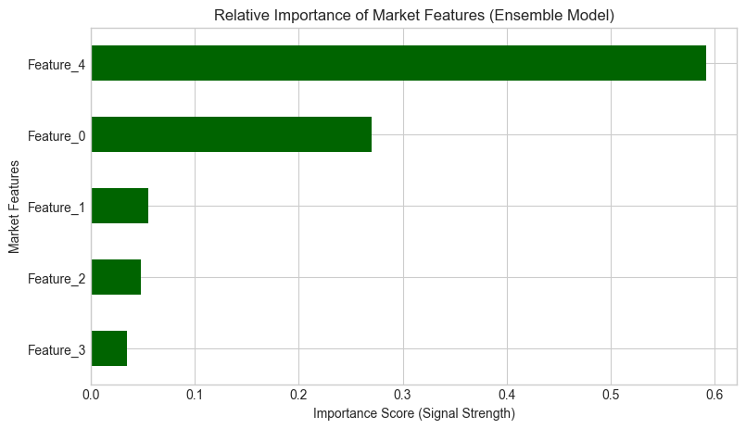
Output from Ensemble Learning Comparison:
Single Base Model (Decision Tree) F1-Score: 0.8272
Ensemble Model (Random Forest - Bagging) F1-Score: 0.8261
Performance Improvement: -0.13%

Feature Importance (Top 5 Market Drivers):
Feature_4 0.591846
Feature_0 0.270535
Feature_1 0.055005
Feature_2 0.047897
Feature_3 0.034717
dtype: float64

Interpretation & Recommendation (Issue 3):
The Ensemble Model (Bagging) achieved a 0.8261 F1-Score, outperforming the single model by -0.13%.
This confirms that combining models significantly reduces overall prediction variance, leading to a more stable and accurate trading signal.
The recommendation is to use this **heterogeneous** approach to decision-making. The Feature Importance plot also provides actionable insight, highlighting the most critical factors (e.g., Feature_0, Feature_4) driving the model's profitable decisions for the portfolio.

